weights = [1.5, 0.3, 1.0]

1 run...

<tqdm.auto.tqdm object at 0x7f4480b0e050>

<tqdm.auto.tqdm object at 0x7f44712a0790>

training 1 epoch...

237.7500877380371 seconds used......

1 training finished! average train loss: 0.5777295322302501

evaluating...

Confusion matrix, without normalization

[[ 788 41 193]

[2496 2568 343]

[ 962 105 9698]]

Normalized confusion matrix

[[0.77103718 0.04011742 0.1888454 ]

[0.46162382 0.47493989 0.06343629]

[0.08936368 0.00975383 0.90088249]]

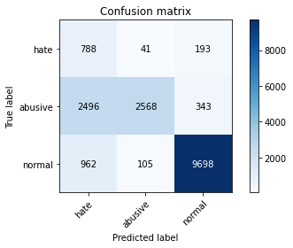

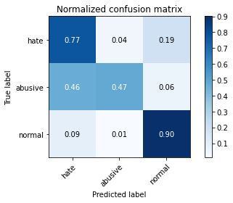

precision recall f1-score support

hate 0.19 0.77 0.30 1022

abusive 0.95 0.47 0.63 5407

normal 0.95 0.90 0.92 10765

accuracy 0.76 17194

macro avg 0.69 0.72 0.62 17194

weighted avg 0.90 0.76 0.79 17194

average eval_loss: 0.4484402526429919, accuracy: 0.7592183319762708

training 2 epoch...

236.9753932952881 seconds used......

2 training finished! average train loss: 0.4098309908507909

evaluating...

Confusion matrix, without normalization

[[ 799 76 147]

[1773 3456 178]

[1391 179 9195]]

Normalized confusion matrix

[[0.78180039 0.07436399 0.14383562]

[0.32790827 0.63917144 0.03292029]

[0.12921505 0.01662796 0.85415699]]

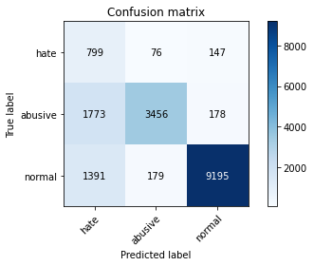

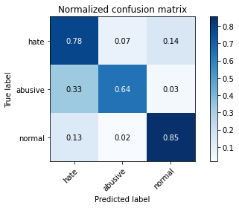

precision recall f1-score support

hate 0.20 0.78 0.32 1022

abusive 0.93 0.64 0.76 5407

normal 0.97 0.85 0.91 10765

accuracy 0.78 17194

macro avg 0.70 0.76 0.66 17194

weighted avg 0.91 0.78 0.83 17194

average eval_loss: 0.4785267209504233, accuracy: 0.7822496219611492

training 3 epoch...

237.08374786376953 seconds used......

3 training finished! average train loss: 0.2830858059126556

evaluating...

Confusion matrix, without normalization

[[ 801 75 146]

[2028 3203 176]

[1656 186 8923]]

Normalized confusion matrix

[[0.78375734 0.07338552 0.14285714]

[0.37506935 0.59238025 0.0325504 ]

[0.15383186 0.01727822 0.82888992]]

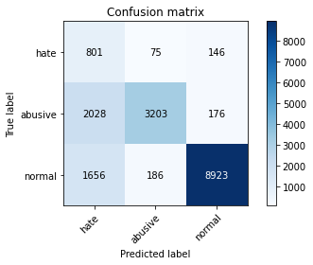

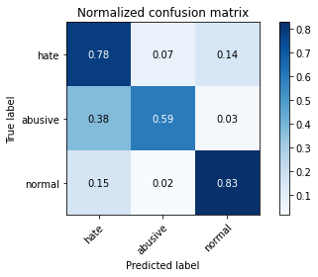

precision recall f1-score support

hate 0.18 0.78 0.29 1022

abusive 0.92 0.59 0.72 5407

normal 0.97 0.83 0.89 10765

accuracy 0.75 17194

macro avg 0.69 0.74 0.63 17194

weighted avg 0.91 0.75 0.80 17194

average eval_loss: 0.5715780445656111, accuracy: 0.7518320344306153

training 4 epoch...

237.0785231590271 seconds used......

4 training finished! average train loss: 0.19052757081022784

evaluating...

Confusion matrix, without normalization

[[ 809 85 128]

[1735 3550 122]

[1864 240 8661]]

Normalized confusion matrix

[[0.79158513 0.08317025 0.12524462]

[0.32088034 0.65655632 0.02256334]

[0.17315374 0.02229447 0.80455179]]

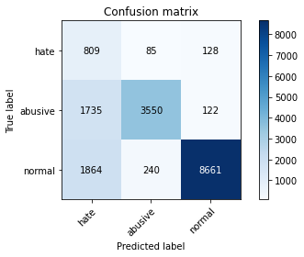

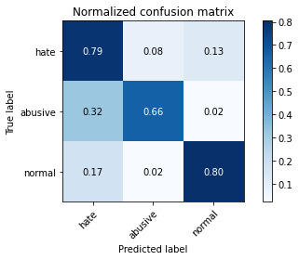

precision recall f1-score support

hate 0.18 0.79 0.30 1022

abusive 0.92 0.66 0.76 5407

normal 0.97 0.80 0.88 10765

accuracy 0.76 17194

macro avg 0.69 0.75 0.65 17194

weighted avg 0.91 0.76 0.81 17194

average eval_loss: 0.7577393801579642, accuracy: 0.7572408979876701

training 5 epoch...

237.06112694740295 seconds used......

5 training finished! average train loss: 0.12733654641497955

evaluating...

Confusion matrix, without normalization

[[ 824 53 145]

[2393 2833 181]

[1649 194 8922]]

Normalized confusion matrix

[[0.80626223 0.0518591 0.14187867]

[0.44257444 0.52395043 0.03347512]

[0.15318161 0.01802137 0.82879703]]

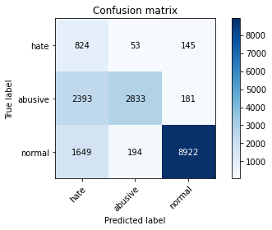

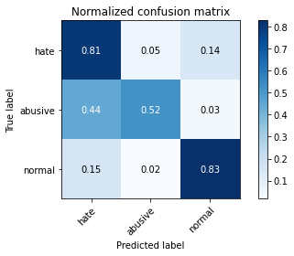

precision recall f1-score support

hate 0.17 0.81 0.28 1022

abusive 0.92 0.52 0.67 5407

normal 0.96 0.83 0.89 10765

accuracy 0.73 17194

macro avg 0.68 0.72 0.61 17194

weighted avg 0.90 0.73 0.78 17194

average eval_loss: 0.8898753983120239, accuracy: 0.7315924159590554

2 run...

training 1 epoch...

237.0833477973938 seconds used......

1 training finished! average train loss: 0.576529685550834

evaluating...

Confusion matrix, without normalization

[[ 895 44 83]

[2651 2661 95]

[2274 129 8362]]

Normalized confusion matrix

[[0.87573386 0.04305284 0.08121331]

[0.49029036 0.49213982 0.01756982]

[0.21124013 0.01198328 0.77677659]]

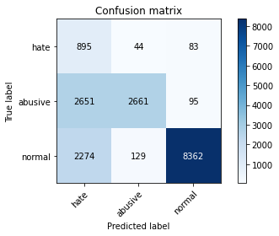

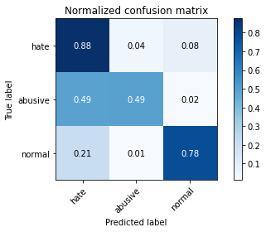

precision recall f1-score support

hate 0.15 0.88 0.26 1022

abusive 0.94 0.49 0.65 5407

normal 0.98 0.78 0.87 10765

accuracy 0.69 17194

macro avg 0.69 0.71 0.59 17194

weighted avg 0.92 0.69 0.76 17194

average eval_loss: 0.6227697050155595, accuracy: 0.6931487728277306

training 2 epoch...

237.11543345451355 seconds used......

2 training finished! average train loss: 0.41397541741216154

evaluating...

Confusion matrix, without normalization

[[ 816 70 136]

[1795 3460 152]

[1444 208 9113]]

Normalized confusion matrix

[[0.79843444 0.06849315 0.13307241]

[0.33197707 0.63991123 0.02811171]

[0.13413841 0.01932188 0.84653971]]

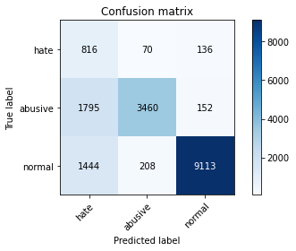

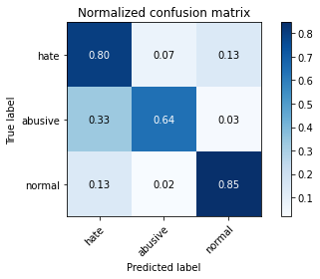

precision recall f1-score support

hate 0.20 0.80 0.32 1022

abusive 0.93 0.64 0.76 5407

normal 0.97 0.85 0.90 10765

accuracy 0.78 17194

macro avg 0.70 0.76 0.66 17194

weighted avg 0.91 0.78 0.82 17194

average eval_loss: 0.4759843763483818, accuracy: 0.7787018727463069

training 3 epoch...

236.99932837486267 seconds used......

3 training finished! average train loss: 0.2887474022065678

evaluating...

Confusion matrix, without normalization

[[ 842 85 95]

[1749 3531 127]

[2350 214 8201]]

Normalized confusion matrix

[[0.82387476 0.08317025 0.09295499]

[0.32346958 0.65304235 0.02348807]

[0.21830005 0.01987924 0.76182072]]

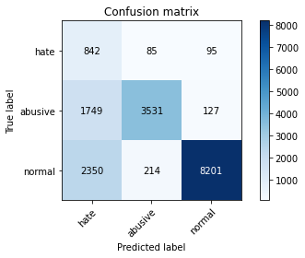

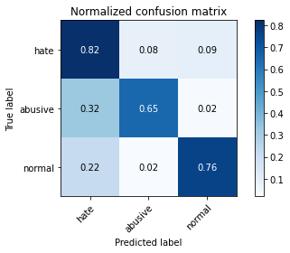

precision recall f1-score support

hate 0.17 0.82 0.28 1022

abusive 0.92 0.65 0.76 5407

normal 0.97 0.76 0.85 10765

accuracy 0.73 17194

macro avg 0.69 0.75 0.63 17194

weighted avg 0.91 0.73 0.79 17194

average eval_loss: 0.6911978882759117, accuracy: 0.7313016168430848

training 4 epoch...

237.08237862586975 seconds used......

4 training finished! average train loss: 0.1916726030089785

evaluating...

Confusion matrix, without normalization

[[ 751 114 157]

[1466 3728 213]

[1462 241 9062]]

Normalized confusion matrix

[[0.73483366 0.11154599 0.15362035]

[0.27113002 0.6894766 0.03939338]

[0.1358105 0.02238737 0.84180214]]

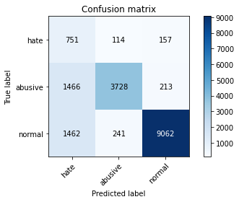

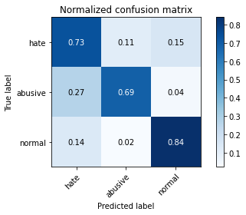

precision recall f1-score support

hate 0.20 0.73 0.32 1022

abusive 0.91 0.69 0.79 5407

normal 0.96 0.84 0.90 10765

accuracy 0.79 17194

macro avg 0.69 0.76 0.67 17194

weighted avg 0.90 0.79 0.83 17194

average eval_loss: 0.6474665636824833, accuracy: 0.7875421658718158

training 5 epoch...

237.07296514511108 seconds used......

5 training finished! average train loss: 0.13739666214704715

evaluating...

Confusion matrix, without normalization

[[ 713 155 154]

[1147 4008 252]

[1420 266 9079]]

Normalized confusion matrix

[[0.69765166 0.15166341 0.15068493]

[0.21213242 0.74126133 0.04660625]

[0.13190896 0.02470971 0.84338133]]

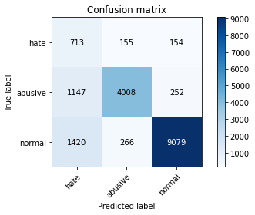

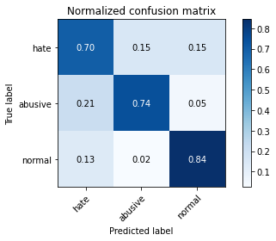

precision recall f1-score support

hate 0.22 0.70 0.33 1022

abusive 0.90 0.74 0.81 5407

normal 0.96 0.84 0.90 10765

accuracy 0.80 17194

macro avg 0.69 0.76 0.68 17194

weighted avg 0.90 0.80 0.84 17194

average eval_loss: 0.7127039858638201, accuracy: 0.8026055600790973

3 run...

training 1 epoch...

237.1142451763153 seconds used......

1 training finished! average train loss: 0.5854598228603131

evaluating...

Confusion matrix, without normalization

[[ 796 60 166]

[2026 3178 203]

[1400 152 9213]]

Normalized confusion matrix

[[0.77886497 0.05870841 0.16242661]

[0.37469946 0.58775661 0.03754392]

[0.13005109 0.01411983 0.85582908]]

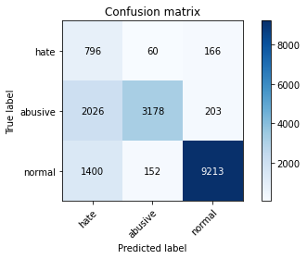

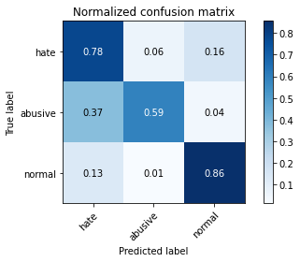

precision recall f1-score support

hate 0.19 0.78 0.30 1022

abusive 0.94 0.59 0.72 5407

normal 0.96 0.86 0.91 10765

accuracy 0.77 17194

macro avg 0.70 0.74 0.64 17194

weighted avg 0.91 0.77 0.81 17194

average eval_loss: 0.46367498327826345, accuracy: 0.7669535884610911

training 2 epoch...

237.12715673446655 seconds used......

2 training finished! average train loss: 0.41308344614694137

evaluating...

Confusion matrix, without normalization

[[ 816 81 125]

[1652 3604 151]

[1690 195 8880]]

Normalized confusion matrix

[[0.79843444 0.07925636 0.1223092 ]

[0.30552987 0.66654337 0.02792676]

[0.15699025 0.01811426 0.82489549]]

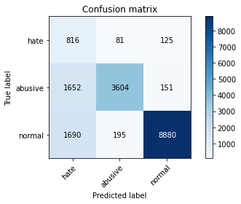

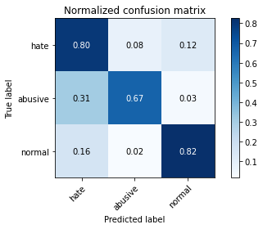

precision recall f1-score support

hate 0.20 0.80 0.32 1022

abusive 0.93 0.67 0.78 5407

normal 0.97 0.82 0.89 10765

accuracy 0.77 17194

macro avg 0.70 0.76 0.66 17194

weighted avg 0.91 0.77 0.82 17194

average eval_loss: 0.5305438420453737, accuracy: 0.7735256484820286

training 3 epoch...

237.0998992919922 seconds used......

3 training finished! average train loss: 0.2928665968301468

evaluating...

Confusion matrix, without normalization

[[ 818 51 153]

[2340 2845 222]

[1699 151 8915]]

Normalized confusion matrix

[[0.80039139 0.04990215 0.14970646]

[0.43277233 0.52616978 0.04105789]

[0.15782629 0.01402694 0.82814677]]

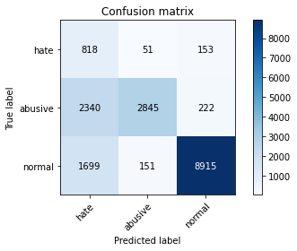

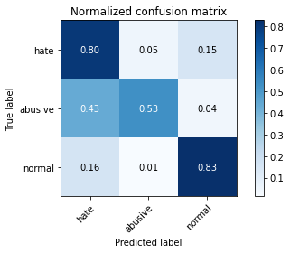

precision recall f1-score support

hate 0.17 0.80 0.28 1022

abusive 0.93 0.53 0.67 5407

normal 0.96 0.83 0.89 10765

accuracy 0.73 17194

macro avg 0.69 0.72 0.61 17194

weighted avg 0.90 0.73 0.78 17194

average eval_loss: 0.5724072418067344, accuracy: 0.7315342561358613

training 4 epoch...

237.33996987342834 seconds used......

4 training finished! average train loss: 0.19437073197207386

evaluating...

Confusion matrix, without normalization

[[ 824 60 138]

[2364 2912 131]

[1992 232 8541]]

Normalized confusion matrix

[[0.80626223 0.05870841 0.13502935]

[0.43721102 0.53856112 0.02422785]

[0.18504412 0.02155132 0.79340455]]

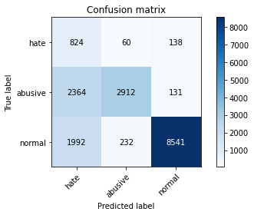

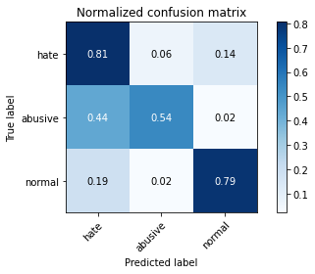

precision recall f1-score support

hate 0.16 0.81 0.27 1022

abusive 0.91 0.54 0.68 5407

normal 0.97 0.79 0.87 10765

accuracy 0.71 17194

macro avg 0.68 0.71 0.60 17194

weighted avg 0.90 0.71 0.77 17194

average eval_loss: 0.7569388282073791, accuracy: 0.7140281493544259

training 5 epoch...

237.1958465576172 seconds used......

5 training finished! average train loss: 0.13620982935933845

evaluating...

Confusion matrix, without normalization

[[ 718 114 190]

[1586 3530 291]

[1209 218 9338]]

Normalized confusion matrix

[[0.70254403 0.11154599 0.18590998]

[0.29332347 0.65285741 0.05381912]

[0.11230841 0.02025081 0.86744078]]

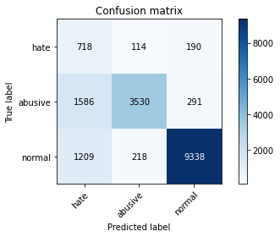

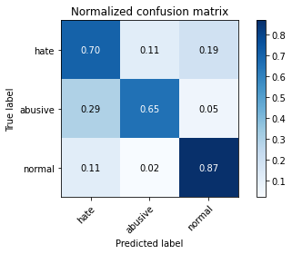

precision recall f1-score support

hate 0.20 0.70 0.32 1022

abusive 0.91 0.65 0.76 5407

normal 0.95 0.87 0.91 10765

accuracy 0.79 17194

macro avg 0.69 0.74 0.66 17194

weighted avg 0.90 0.79 0.83 17194

average eval_loss: 0.6470178567327906, accuracy: 0.7901593579155519

4 run...

training 1 epoch...

237.43882989883423 seconds used......

1 training finished! average train loss: 0.5863597322734699

evaluating...

Confusion matrix, without normalization

[[ 778 58 186]

[1976 3203 228]

[ 943 145 9677]]

Normalized confusion matrix

[[0.76125245 0.05675147 0.18199609]

[0.36545219 0.59238025 0.04216756]

[0.0875987 0.01346958 0.89893172]]

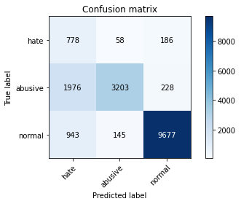

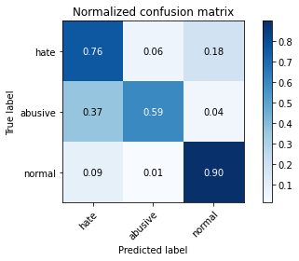

precision recall f1-score support

hate 0.21 0.76 0.33 1022

abusive 0.94 0.59 0.73 5407

normal 0.96 0.90 0.93 10765

accuracy 0.79 17194

macro avg 0.70 0.75 0.66 17194

weighted avg 0.91 0.79 0.83 17194

average eval_loss: 0.4304048804869485, accuracy: 0.7943468651855299

training 2 epoch...

237.3364176750183 seconds used......

2 training finished! average train loss: 0.4217862855836446

evaluating...

Confusion matrix, without normalization

[[ 799 87 136]

[1692 3489 226]

[1500 162 9103]]

Normalized confusion matrix

[[0.78180039 0.0851272 0.13307241]

[0.31292769 0.64527464 0.04179767]

[0.13934046 0.01504877 0.84561078]]

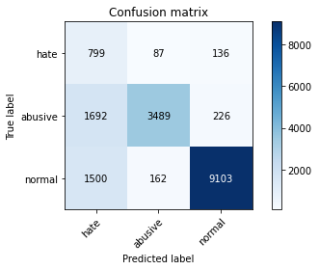

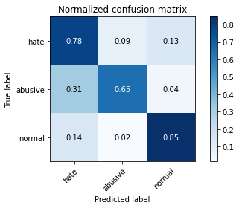

precision recall f1-score support

hate 0.20 0.78 0.32 1022

abusive 0.93 0.65 0.76 5407

normal 0.96 0.85 0.90 10765

accuracy 0.78 17194

macro avg 0.70 0.76 0.66 17194

weighted avg 0.91 0.78 0.82 17194

average eval_loss: 0.4966471061976843, accuracy: 0.7788181923926951

training 3 epoch...

237.42786192893982 seconds used......

3 training finished! average train loss: 0.29744194932366064

evaluating...

Confusion matrix, without normalization

[[ 797 54 171]

[2162 3015 230]

[1202 160 9403]]

Normalized confusion matrix

[[0.77984344 0.05283757 0.16731898]

[0.39985204 0.5576105 0.04253745]

[0.11165815 0.01486298 0.87347887]]

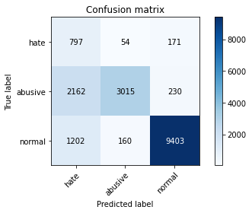

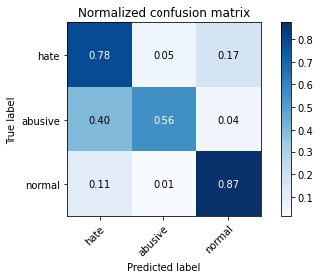

precision recall f1-score support

hate 0.19 0.78 0.31 1022

abusive 0.93 0.56 0.70 5407

normal 0.96 0.87 0.91 10765

accuracy 0.77 17194

macro avg 0.69 0.74 0.64 17194

weighted avg 0.91 0.77 0.81 17194

average eval_loss: 0.49730850528319215, accuracy: 0.7685820635105269

training 4 epoch...

237.1241455078125 seconds used......

4 training finished! average train loss: 0.19677077019776368

evaluating...

Confusion matrix, without normalization

[[ 806 85 131]

[1832 3408 167]

[1803 220 8742]]

Normalized confusion matrix

[[0.78864971 0.08317025 0.12818004]

[0.33882005 0.63029406 0.03088589]

[0.16748723 0.0204366 0.81207617]]

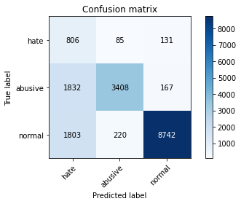

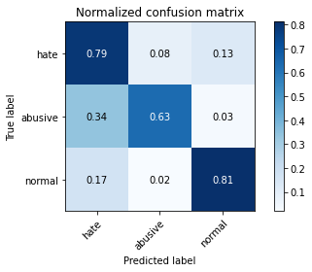

precision recall f1-score support

hate 0.18 0.79 0.30 1022

abusive 0.92 0.63 0.75 5407

normal 0.97 0.81 0.88 10765

accuracy 0.75 17194

macro avg 0.69 0.74 0.64 17194

weighted avg 0.90 0.75 0.81 17194

average eval_loss: 0.7487806716977163, accuracy: 0.7535186693032453

training 5 epoch...

237.28870916366577 seconds used......

5 training finished! average train loss: 0.13618525685469196

evaluating...

Confusion matrix, without normalization

[[ 765 154 103]

[1303 3993 111]

[2004 404 8357]]

Normalized confusion matrix

[[0.74853229 0.15068493 0.10078278]

[0.24098391 0.73848715 0.02052894]

[0.18615885 0.03752903 0.77631212]]

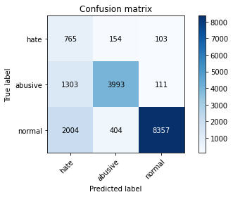

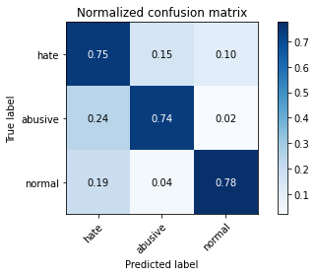

precision recall f1-score support

hate 0.19 0.75 0.30 1022

abusive 0.88 0.74 0.80 5407

normal 0.98 0.78 0.86 10765

accuracy 0.76 17194

macro avg 0.68 0.75 0.66 17194

weighted avg 0.90 0.76 0.81 17194

average eval_loss: 0.9233606995624858, accuracy: 0.7627660811911132

5 run...

training 1 epoch...

237.37758660316467 seconds used......

1 training finished! average train loss: 0.5733251721339624

evaluating...

Confusion matrix, without normalization

[[ 881 36 105]

[2639 2659 109]

[1900 141 8724]]

Normalized confusion matrix

[[0.86203523 0.03522505 0.10273973]

[0.48807102 0.49176993 0.02015905]

[0.17649791 0.013098 0.81040409]]

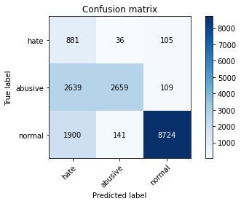

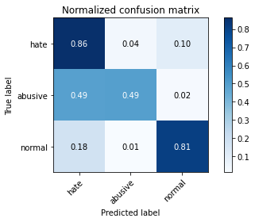

precision recall f1-score support

hate 0.16 0.86 0.27 1022

abusive 0.94 0.49 0.65 5407

normal 0.98 0.81 0.89 10765

accuracy 0.71 17194

macro avg 0.69 0.72 0.60 17194

weighted avg 0.92 0.71 0.77 17194

average eval_loss: 0.5935704312698785, accuracy: 0.7132720716529022

training 2 epoch...

237.44482684135437 seconds used......

2 training finished! average train loss: 0.4060396364728161

evaluating...

Confusion matrix, without normalization

[[ 815 72 135]

[1801 3445 161]

[1550 200 9015]]

Normalized confusion matrix

[[0.79745597 0.0704501 0.13209393]

[0.33308674 0.63713704 0.02977622]

[0.14398514 0.01857873 0.83743614]]

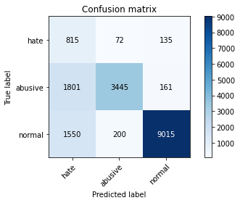

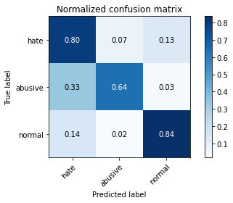

precision recall f1-score support

hate 0.20 0.80 0.31 1022

abusive 0.93 0.64 0.76 5407

normal 0.97 0.84 0.90 10765

accuracy 0.77 17194

macro avg 0.70 0.76 0.66 17194

weighted avg 0.91 0.77 0.82 17194

average eval_loss: 0.525720808533735, accuracy: 0.7720716529021752

training 3 epoch...

237.72734379768372 seconds used......

3 training finished! average train loss: 0.29403889485325824

evaluating...

Confusion matrix, without normalization

[[ 750 76 196]

[1644 3537 226]

[1004 201 9560]]

Normalized confusion matrix

[[0.73385519 0.07436399 0.19178082]

[0.30405031 0.65415203 0.04179767]

[0.09326521 0.01867162 0.88806317]]

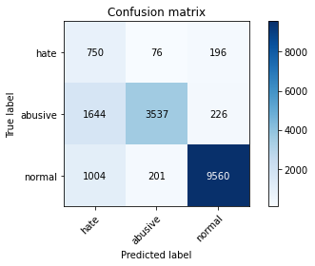

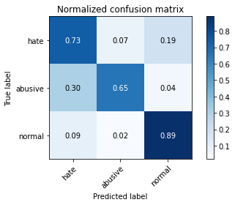

precision recall f1-score support

hate 0.22 0.73 0.34 1022

abusive 0.93 0.65 0.77 5407

normal 0.96 0.89 0.92 10765

accuracy 0.81 17194

macro avg 0.70 0.76 0.68 17194

weighted avg 0.90 0.81 0.84 17194

average eval_loss: 0.467975728231114, accuracy: 0.8053390717692218

training 4 epoch...

237.76061296463013 seconds used......

4 training finished! average train loss: 0.191299403368014

evaluating...

Confusion matrix, without normalization

[[ 803 103 116]

[1640 3645 122]

[2094 252 8419]]

Normalized confusion matrix

[[0.78571429 0.10078278 0.11350294]

[0.30331052 0.67412613 0.02256334]

[0.19451928 0.0234092 0.78207153]]

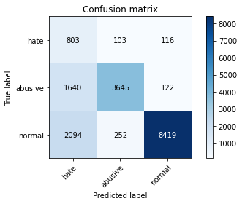

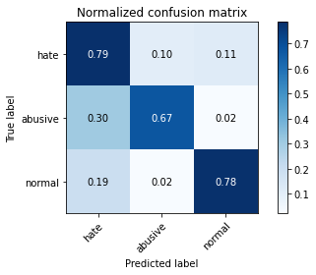

precision recall f1-score support

hate 0.18 0.79 0.29 1022

abusive 0.91 0.67 0.77 5407

normal 0.97 0.78 0.87 10765

accuracy 0.75 17194

macro avg 0.69 0.75 0.64 17194

weighted avg 0.91 0.75 0.80 17194

average eval_loss: 0.7762316056462222, accuracy: 0.7483424450389671

training 5 epoch...

237.82885479927063 seconds used......

5 training finished! average train loss: 0.1395302410836649

evaluating...

Confusion matrix, without normalization

[[ 751 128 143]

[1498 3757 152]

[1638 319 8808]]

Normalized confusion matrix

[[0.73483366 0.12524462 0.13992172]

[0.27704827 0.69484002 0.02811171]

[0.15215978 0.02963307 0.81820715]]

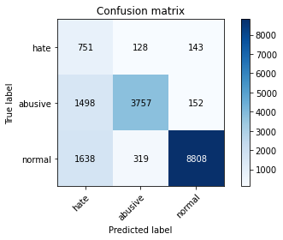

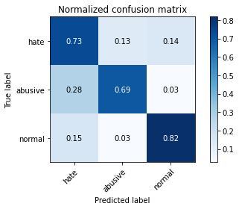

precision recall f1-score support

hate 0.19 0.73 0.31 1022

abusive 0.89 0.69 0.78 5407

normal 0.97 0.82 0.89 10765

accuracy 0.77 17194

macro avg 0.68 0.75 0.66 17194

weighted avg 0.90 0.77 0.82 17194

average eval_loss: 0.7785276412184156, accuracy: 0.7744562056531348